

OUTLOOK INstallation guide

Date Updated: 05/16/17



Outlook Installation Guide

Sherpa | 3030 Locust Street

St. Louis, MO 63103 | (314) 432-1234

Table of Contents

Introduction 2

For IT Admins 2

For Single Users 3

Questions 5

# Introduction

W

elcome, Sherpa users! This guide will show you how to install the Sherpa add-in with your Microsoft Outlook account so you can create sales notes in Sherpa from your inbox, sync your Sherpa calendar with Outlook and seamlessly update events on both calendars with the push of a button.

If you have questions throughout this guide, please contact our Customer Experience team at (314) 432-1234 or by email at support@sherpacrm.com.

# For IT Admins

Introduction

You can install or remove add-ins for Outlook for your organization by using the EAC (exchange admin center). By default, after you install an add-in for your organization, the add-in is available for all users in your organization. After installation, you can use the EAC to make the add-in optional or required for your users, and to specify whether you want the add-in to be enabled or disabled.

### Installation

* 1. Use the EAC to add an add-in.
  2. In the EAC, navigate to Organization > Add-ins.
  3. Click New +, and then choose the location that you want to install the add-in from. For the Sherpa add-in choose “Add from URL.” In the URL, enter <https://members.sherpacrm.com/bundles/outlook/sherpa-outlook-manifest.xml>
  4. Click Save.

Manage user access

* 1. Use the EAC to add an add-in.
  2. In the EAC, navigate to Organization > Add-ins.
  3. In the list view, select the Sherpa add-in to change the settings, and then click Edit.
  4. If you don’t want your users to use the add-in, clear the Make this add-in available to users in your organization check box, and then click Save.
  5. If you want your users to be able to use the add-in, select Make this add-in available to users in your organization, and then select the option you want.
* **Optional, enabled by default** Use this setting if you want to allow your users to turn off the add-in.
* **Optional, disabled by default** Use this setting if you want to allow your users to turn on the add-in.
* **Mandatory, always enabled. Users can’t disable this add-in** Use this setting if you don’t want your users to turn off the add-in.

6. Click Save.

# For Single Users

Introduction

You can install or remove add-ins for Outlook from the browser or desktop application. In the desktop application, it is easiest to install the add-in from the Office Store. For the browser, you can add the add-in through the settings and managing integrations.

Adding through Desktop Application

* 1. In Outlook, click Home > store on the ribbon.

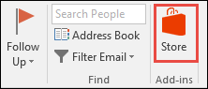

* 1. On the Add-Ins for Outlook page, click on the Click here to add a custom add-in and select Add from URL…

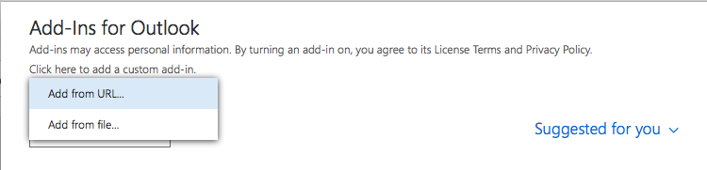

* 1. In the URL, enter <https://members.sherpacrm.com/bundles/outlook/sherpa-outlook-manifest.xml>

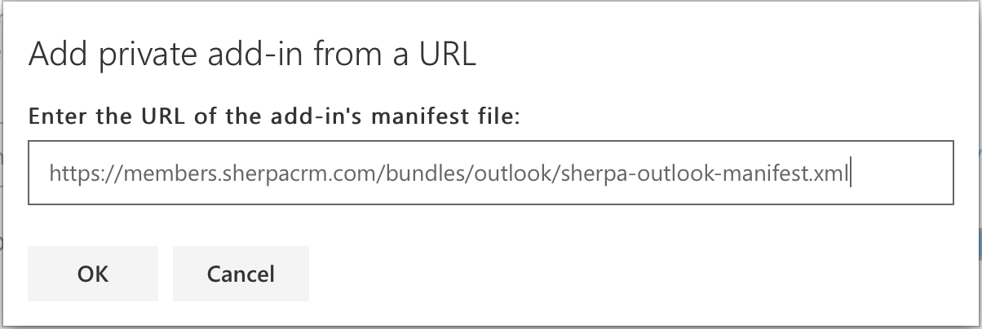

* 1. Click OK and then Install on the next prompt.
  2. When the add-in is installed, go to File > Manage Add-ins or Manage Apps to make sure it's turned on. When you’re prompted to sign in, type the email address and password you use to sign in to Office programs

Adding through web browser

1. In Outlook Mail, click on the settings button that logs like a cog wheel in the upper right corner.

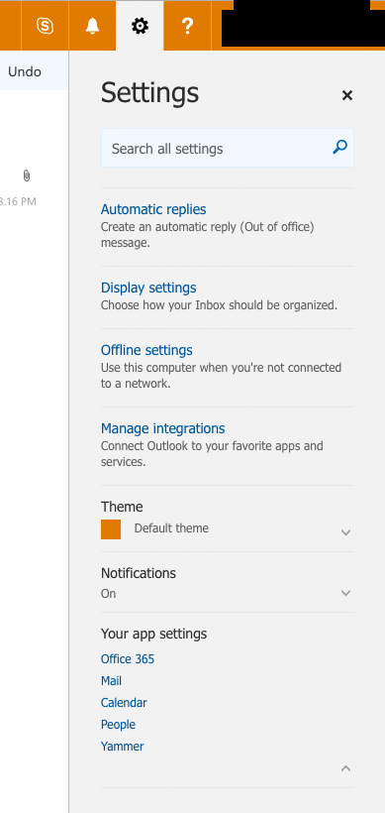

1. Click on Manage Integrations.
2. On the Add-Ins page, click on the Click here to add a custom add-in and select Add from URL…



1. In the URL, enter <https://members.sherpacrm.com/bundles/outlook/sherpa-outlook-manifest.xml>



1. Click OK and then Install on the next prompt.
2. When the add-in is installed, go to File > Manage Add-ins or Manage Apps to make sure it's turned on. When you’re prompted to sign in, type the email address and password you use to sign in to Office programs

# Questions

Questions? Please reach out to our Customer Experience team at support@sherpacrm.com or give us a call at (314) 432-1234.